NAME- PUJAN RASTOGI

EMAIL – [rastogipujan59@gmail.com](mailto:rastogipujan59@gmail.com)

**ASSESSMENT 3**

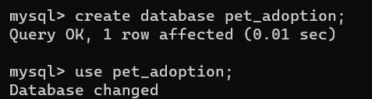

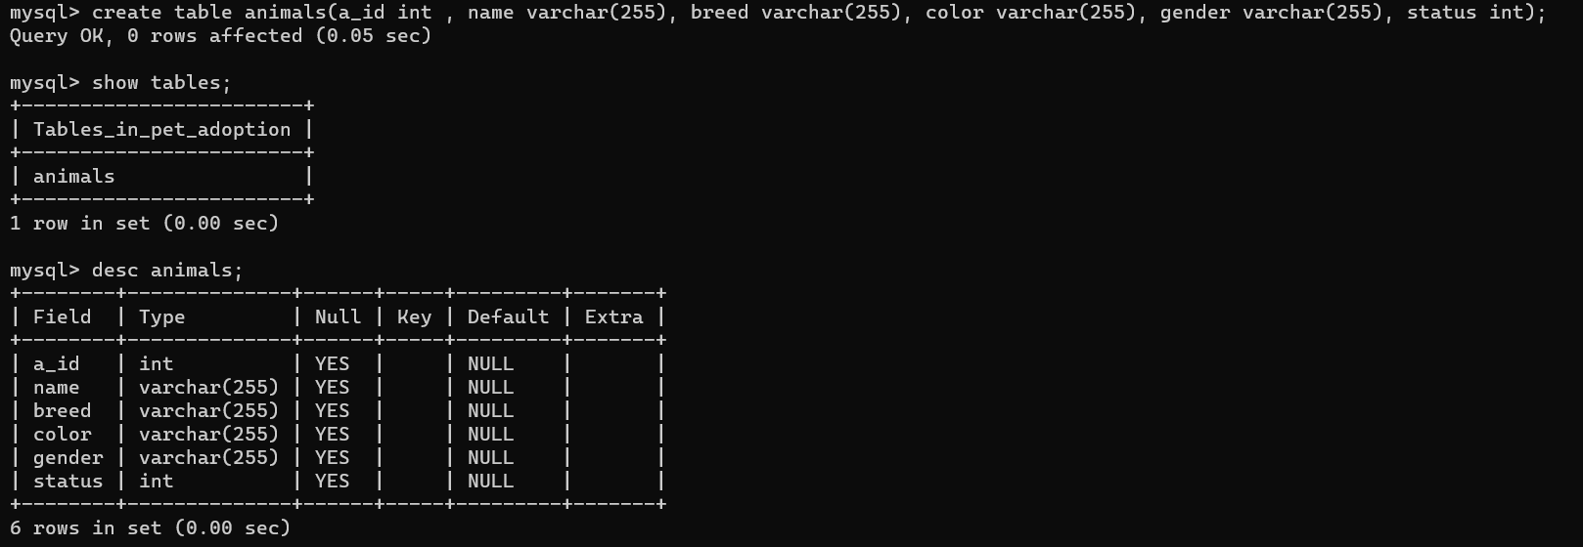

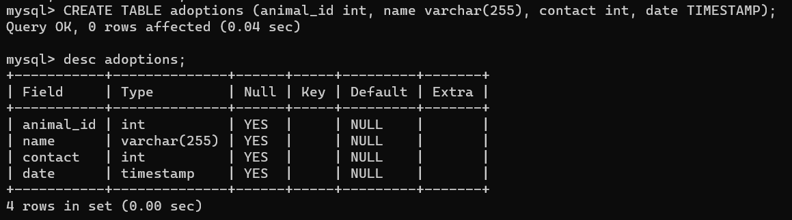

**Exercise 1: Add All Dogs to the Database**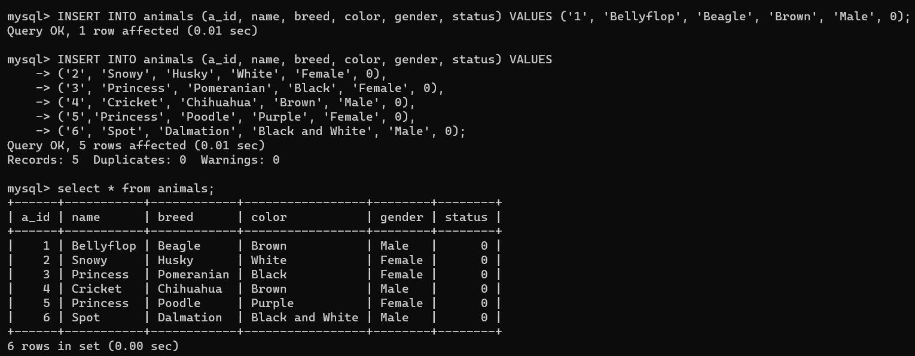

**Retrieve List of Dogs: SELECT * FROM**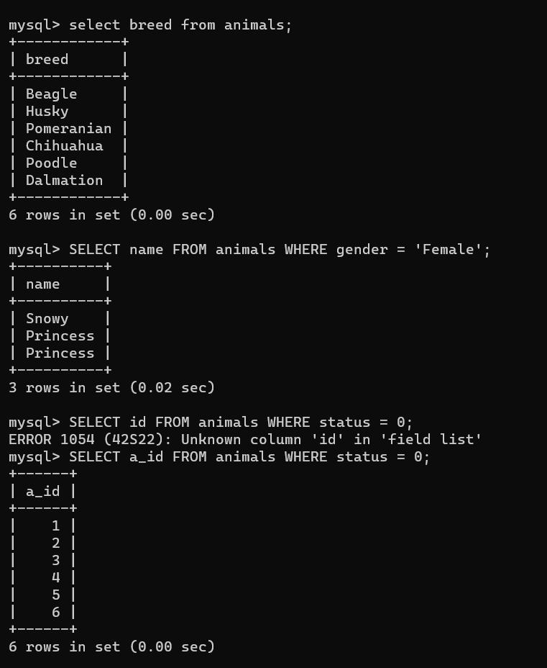

**Update Dogs’ Information: UPDATE & DELETE FROM**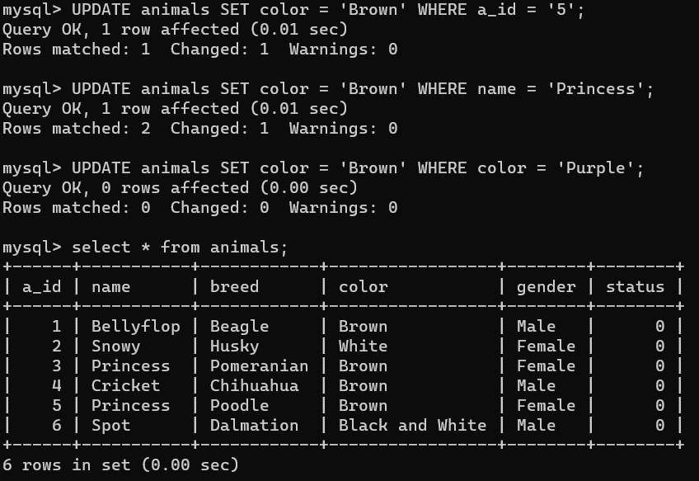

**Our First Shelter Adoption: UPDATE & INSERT**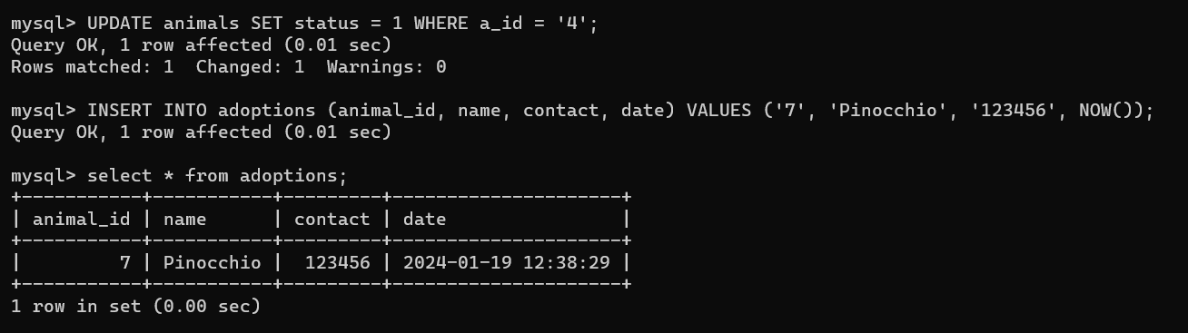

**Exercise 2: Record Adoptions**

**Verify Changes: ORDER BY**

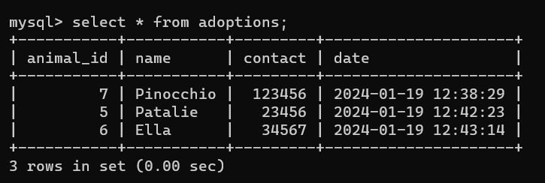

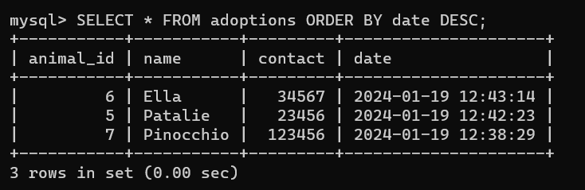

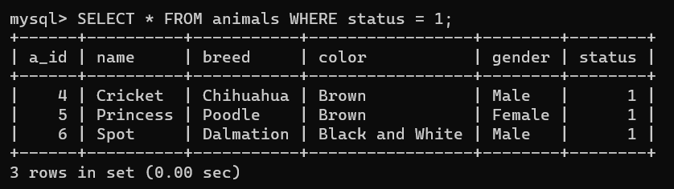

**Advanced: Now Accepting Cats for Adoption**

**Add a Table Column: ALTER TABLE**

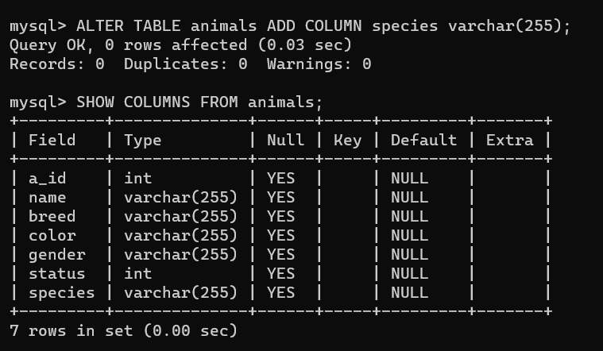

**Set All Current Animals to “Dog”: SET & UPDATE**

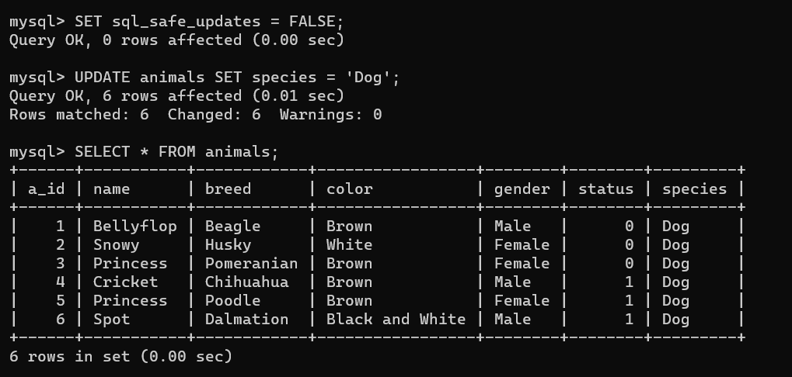

**Bring In The Cats**

**Exercise 3: Add All Cats to the Database**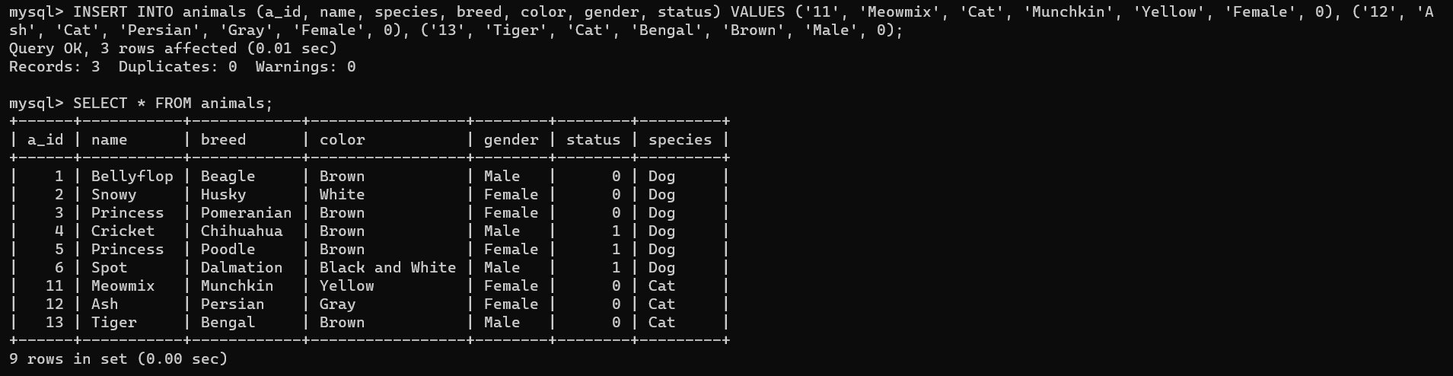

**Advanced: Expand to Multiple Locations**

**A Table for Shelters: ALTER TABLE … ADD COLUMN**

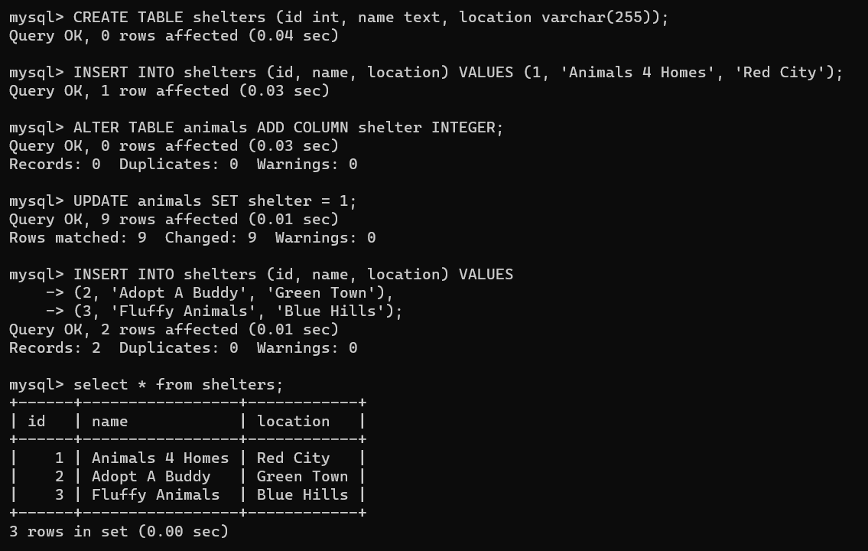

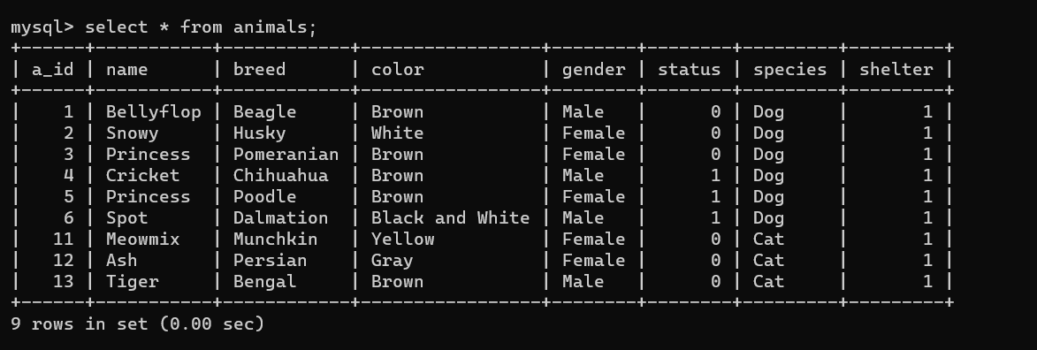

**New Animals for New Homes**

**Exercise 4: Add Many Types of Animals**

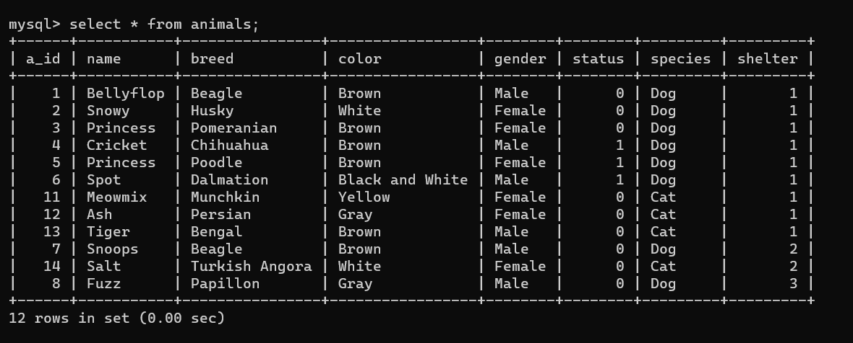

**More Advanced SQL: Indexes and Joins**

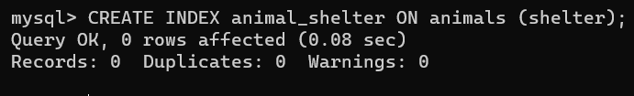

**Complex Queries with JOIN**

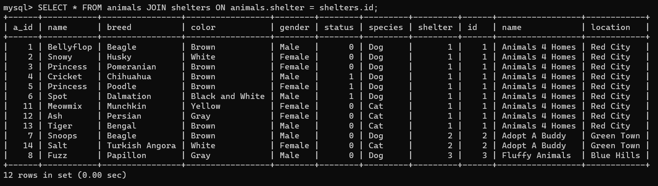

**Exercise 5: Get list of all animals**

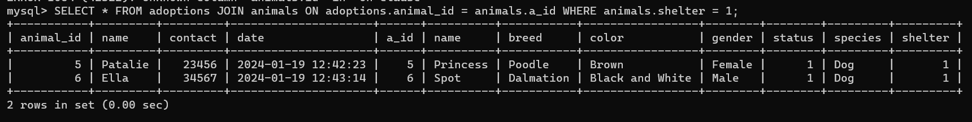

**Types of Logical Operators in SQL**

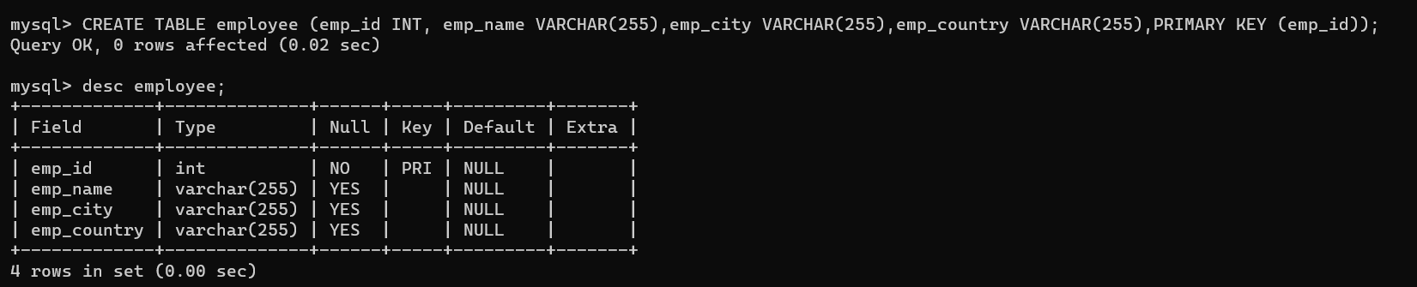

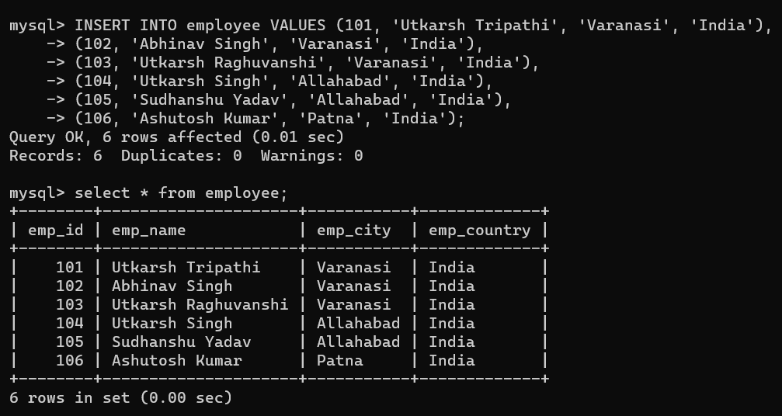

**AND Operator**

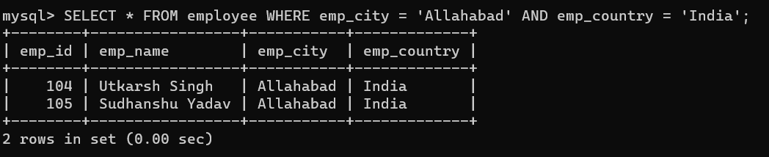

**IN Operator**

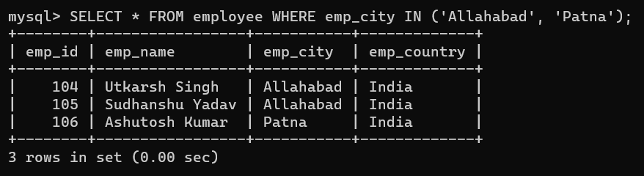

**NOT Operator**

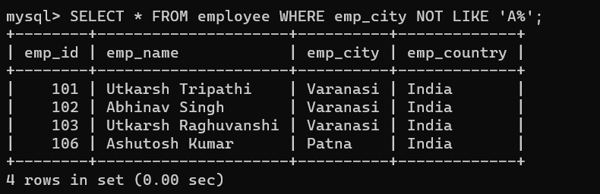

**OR Operator**

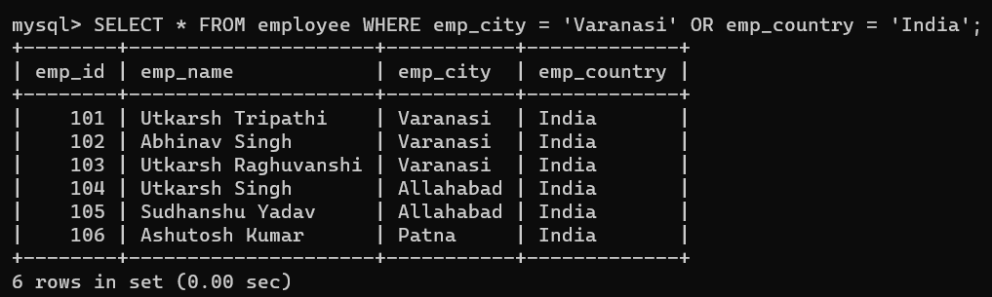

**LIKE Operator**

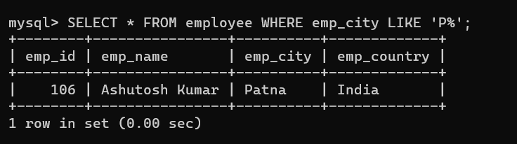

**BETWEEN Operator**

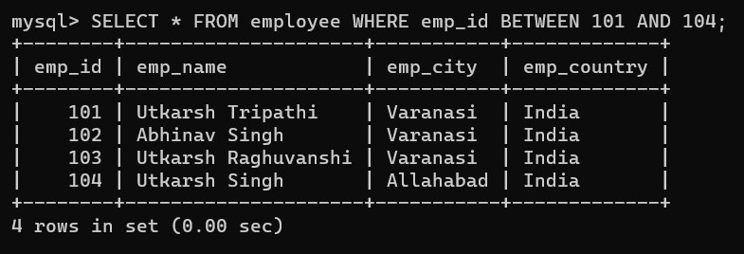

**ALL Operator**

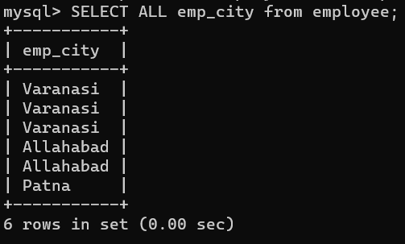

**ANY Operator**

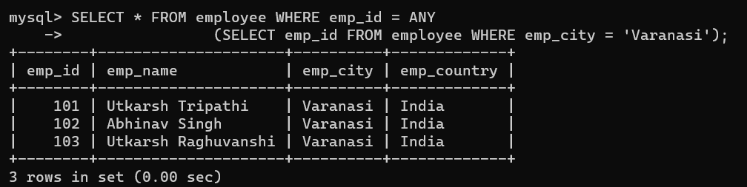

**EXISTS Operator**

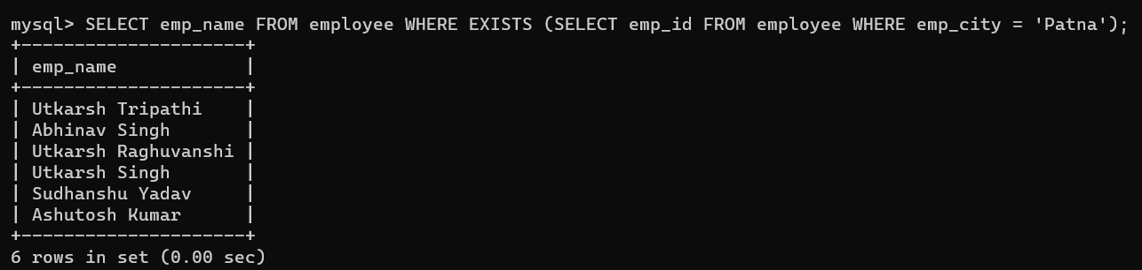

**SOME Operator**

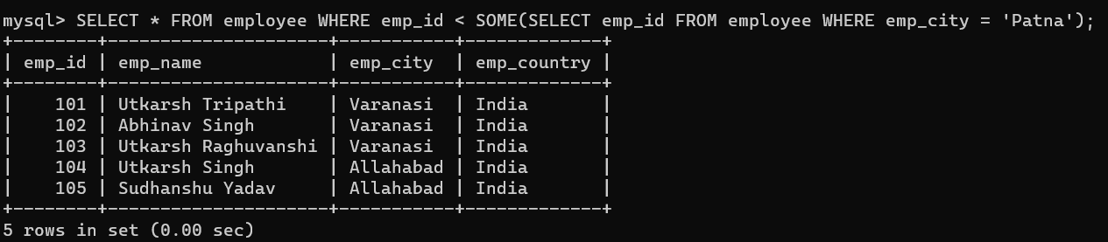

SQL Distinct Clause

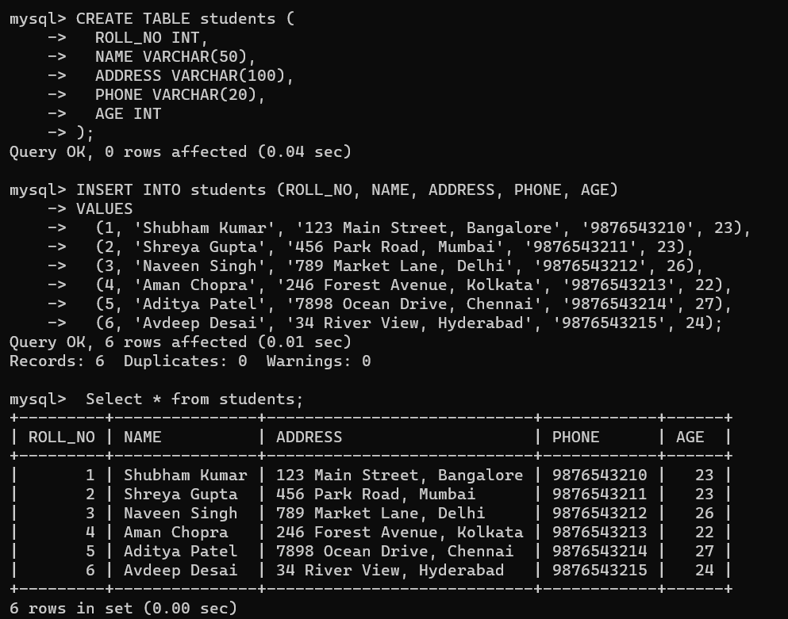

**Distinct Operations**

**Example 1: Now, to fetch unique names from the NAME field.**

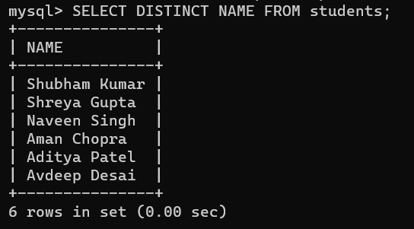

**Example 2: Now, to fetch a unique combination of rows from the whole table.**

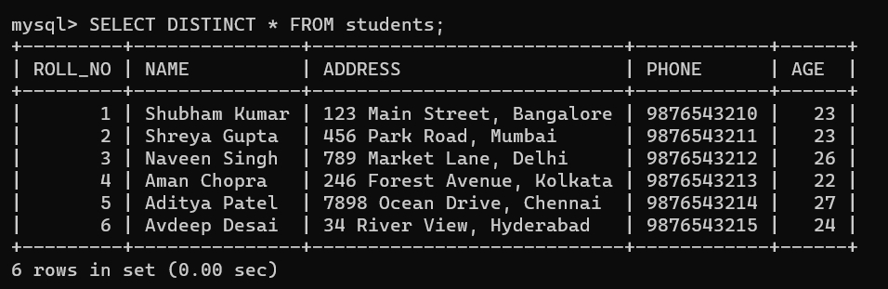

**Using Distinct Clause with Group By & Order By**

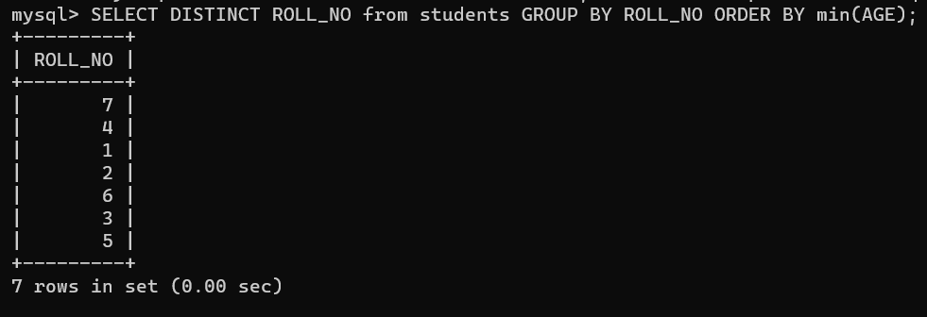

**Using Distinct Clause with COUNT() Function**

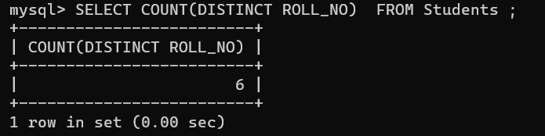

**How the DISTINCT Clause Handles NULL Values?**

